**Question 1**

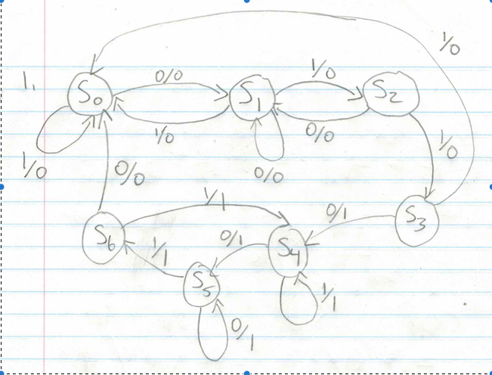

State and Output Table

|  |  |  |  |  |  |  |  |  |
| --- | --- | --- | --- | --- | --- | --- | --- | --- |
|  | Current States | | | Input | Next States | | | Output |
|  | q2 | q1 | q0 | x | q2 | q1 | q0 | z |
| s0 | 0 | 0 | 0 | 0 | 0 | 0 | 1 | 0 |
|  | 0 | 0 | 0 | 1 | 0 | 0 | 0 | 0 |
| s1 | 0 | 0 | 1 | 0 | 0 | 0 | 1 | 0 |
|  | 0 | 0 | 1 | 1 | 0 | 1 | 0 | 0 |
| s2 | 0 | 1 | 0 | 0 | 0 | 0 | 1 | 0 |
|  | 0 | 1 | 0 | 1 | 0 | 1 | 1 | 0 |
| s3 | 0 | 1 | 1 | 0 | 1 | 0 | 0 | 1 |
|  | 0 | 1 | 1 | 1 | 0 | 0 | 0 | 0 |
| s4 | 1 | 0 | 0 | 0 | 1 | 0 | 1 | 1 |
|  | 1 | 0 | 0 | 1 | 1 | 0 | 0 | 1 |
| s5 | 1 | 0 | 1 | 0 | 1 | 0 | 1 | 1 |
|  | 1 | 0 | 1 | 1 | 1 | 1 | 0 | 1 |
| s6 | 1 | 1 | 0 | 0 | 0 | 0 | 0 | 0 |
|  | 1 | 1 | 0 | 1 | 1 | 0 | 0 | 1 |

**Question 2**

|  |  |  |  |  |  |  |  |  |  |  |
| --- | --- | --- | --- | --- | --- | --- | --- | --- | --- | --- |
| Current State | | Inputs | | Next State | | output | Flip Flop Inputs | | | |
| a | b | x | y | a(n) | b(n) | z | Ja | Ka | Jb | Kb |
| 0 | 0 | 0 | 0 | 0 | 0 | 0 | 0 | x | 0 | x |
| 0 | 0 | 0 | 1 | 0 | 1 | 0 | 0 | x | 1 | x |
| 0 | 0 | 1 | 0 | 1 | 0 | 1 | 1 | x | 0 | x |
| 0 | 0 | 1 | 1 | 1 | 1 | 1 | 1 | x | 1 | x |
| 0 | 1 | 0 | 0 | 0 | 1 | 1 | 0 | x | x | 0 |
| 0 | 1 | 0 | 1 | 1 | 0 | 1 | 1 | x | x | 1 |
| 0 | 1 | 1 | 0 | 1 | 0 | 0 | 1 | x | x | 1 |
| 0 | 1 | 1 | 1 | 0 | 0 | 0 | 0 | x | x | 1 |
| 1 | 0 | 0 | 0 | 1 | 1 | 1 | x | 0 | 1 | x |
| 1 | 0 | 0 | 1 | 1 | 1 | 0 | x | 0 | 1 | x |
| 1 | 0 | 1 | 0 | 1 | 1 | 1 | x | 0 | 1 | x |
| 1 | 0 | 1 | 1 | 1 | 0 | 0 | x | 0 | 0 | x |
| 1 | 1 | 0 | 0 | 0 | 0 | 0 | x | 1 | x | 1 |
| 1 | 1 | 0 | 1 | 0 | 0 | 1 | x | 1 | x | 1 |
| 1 | 1 | 1 | 0 | 0 | 0 | 0 | x | 1 | x | 1 |
| 1 | 1 | 1 | 1 | 0 | 1 | 1 | x | 1 | x | 1 |





**Question 3 (Textbook 4: 5-14)**

3a)

|  |  |  |  |  |
| --- | --- | --- | --- | --- |
| Current State | Inputs |  | Next State | Output |
|  | x1 | x2 |  | z |
| A | 0 | 0 | A | 0 |
|  | 0 | 1 | B | 0 |
|  | 1 | 0 | B | 1 |
|  | 1 | 1 | A | 0 |
| B | 0 | 0 | A | 0 |
|  | 0 | 1 | A | 0 |
|  | 1 | 0 | D | 1 |
|  | 1 | 1 | D | 1 |
| C | 0 | 0 | A | 1 |
|  | 0 | 1 | A | 0 |
|  | 1 | 0 | C | 1 |
|  | 1 | 1 | C | 0 |
| D | 0 | 0 | C | 1 |
|  | 0 | 1 | B | 1 |
|  | 1 | 0 | B | 0 |
|  | 1 | 1 | C | 1 |

3b)

|  |  |  |  |  |  |  |
| --- | --- | --- | --- | --- | --- | --- |
| Current State | | Inputs | | Next State | | output |
| a | b | x1 | x2 | a(n) | b(n) | z |
| 0 | 0 | 0 | 0 | 0 | 0 | 0 |
| 0 | 0 | 0 | 1 | 0 | 1 | 0 |
| 0 | 0 | 1 | 0 | 0 | 1 | 1 |
| 0 | 0 | 1 | 1 | 0 | 0 | 0 |
| 0 | 1 | 0 | 0 | 0 | 0 | 0 |
| 0 | 1 | 0 | 1 | 0 | 0 | 0 |
| 0 | 1 | 1 | 0 | 1 | 1 | 1 |
| 0 | 1 | 1 | 1 | 1 | 1 | 1 |
| 1 | 0 | 0 | 0 | 0 | 0 | 1 |
| 1 | 0 | 0 | 1 | 0 | 0 | 0 |
| 1 | 0 | 1 | 0 | 1 | 0 | 1 |
| 1 | 0 | 1 | 1 | 1 | 0 | 0 |
| 1 | 1 | 0 | 0 | 1 | 0 | 1 |
| 1 | 1 | 0 | 1 | 0 | 1 | 1 |
| 1 | 1 | 1 | 0 | 0 | 1 | 0 |
| 1 | 1 | 1 | 1 | 1 | 0 | 1 |

3c)

|  |  |  |  |  |  |  |  |  |
| --- | --- | --- | --- | --- | --- | --- | --- | --- |
| Current State | | Inputs | | Next State | | output | Flip Flop Inputs | |
| a | b | x1 | x2 | a(n) | b(n) | z | Da | Db |
| 0 | 0 | 0 | 0 | 0 | 0 | 0 | 0 | 0 |
| 0 | 0 | 0 | 1 | 0 | 1 | 0 | 0 | 1 |
| 0 | 0 | 1 | 0 | 0 | 1 | 1 | 0 | 1 |
| 0 | 0 | 1 | 1 | 0 | 0 | 0 | 0 | 0 |
| 0 | 1 | 0 | 0 | 0 | 0 | 0 | 0 | 0 |
| 0 | 1 | 0 | 1 | 0 | 0 | 0 | 0 | 0 |
| 0 | 1 | 1 | 0 | 1 | 1 | 1 | 1 | 1 |
| 0 | 1 | 1 | 1 | 1 | 1 | 1 | 1 | 1 |
| 1 | 0 | 0 | 0 | 0 | 0 | 1 | 0 | 0 |
| 1 | 0 | 0 | 1 | 0 | 0 | 0 | 0 | 0 |
| 1 | 0 | 1 | 0 | 1 | 0 | 1 | 1 | 0 |
| 1 | 0 | 1 | 1 | 1 | 0 | 0 | 1 | 0 |
| 1 | 1 | 0 | 0 | 1 | 0 | 1 | 1 | 0 |
| 1 | 1 | 0 | 1 | 0 | 1 | 1 | 0 | 1 |
| 1 | 1 | 1 | 0 | 0 | 1 | 0 | 0 | 1 |
| 1 | 1 | 1 | 1 | 1 | 0 | 1 | 1 | 0 |

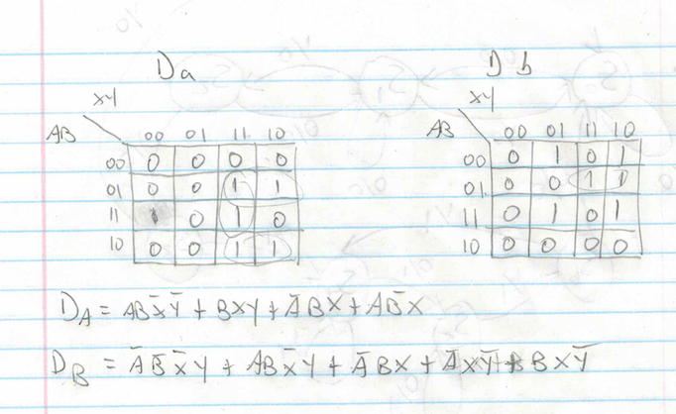

**Question 4**

|  |  |  |  |  |  |
| --- | --- | --- | --- | --- | --- |
| Current State | | Inputs | | Next State Flip Flop | |
| Q | Q' | G | L | Q | Q' |
| 0 | 1 | 0 | 0 | 0 | 1 |
|  |  | 0 | 1 | 0 | 1 |
|  |  | 1 | 0 | 0 | 1 |
|  |  | 1 | 1 | 1 | 0 |
| 1 | 0 | 0 | 0 | 1 | 0 |
|  |  | 0 | 1 | 1 | 0 |
|  |  | 1 | 0 | 0 | 1 |
|  |  | 1 | 1 | 1 | 1 |

**Question 5**

**Question 6**

**Question 7 (Textbook: 5-22)**

**7a)**

**7b)**

|  |  |  |  |  |
| --- | --- | --- | --- | --- |
| Current State | Message Bit | Next State | Output | D Flip Flop |
| 0 | 0 | 1 | 1 | 1 |
| 0 | 1 | 0 | 0 | 0 |
| 1 | 0 | 0 | 0 | 0 |
| 1 | 1 | 1 | 1 | 1 |

**Question 8 (Textbook 4: 5-24)**

**8a)**

**8b)**

|  |  |  |  |  |  |  |  |  |
| --- | --- | --- | --- | --- | --- | --- | --- | --- |
| Current State | | | Inputs | | Next State | | | Output |
| a | b | c | R | A | a+ | b+ | c+ | e |
| 0 | 0 | 0 | 0 | 0 | 0 | 0 | 0 | 0 |
|  |  |  | 0 | 1 | 0 | 0 | 0 | 0 |
|  |  |  | 1 | 0 | 0 | 0 | 1 | 0 |
|  |  |  | 1 | 1 | 1 | 0 | 0 | 1 |
| 0 | 0 | 1 | 0 | 0 | 0 | 0 | 0 | 0 |
|  |  |  | 0 | 1 | 0 | 0 | 0 | 0 |
|  |  |  | 1 | 0 | 0 | 0 | 1 | 0 |
|  |  |  | 1 | 1 | 0 | 1 | 0 | 0 |
| 0 | 1 | 0 | 0 | 0 | 1 | 0 | 0 | 1 |
|  |  |  | 0 | 1 | 0 | 1 | 1 | 0 |
|  |  |  | 1 | 0 | 1 | 0 | 0 | 1 |
|  |  |  | 1 | 1 | 0 | 1 | 0 | 0 |
| 0 | 1 | 1 | 0 | 0 | 0 | 0 | 0 | 0 |
|  |  |  | 0 | 1 | 0 | 1 | 1 | 0 |
|  |  |  | 1 | 0 | 1 | 0 | 0 | 1 |
|  |  |  | 1 | 1 | 1 | 0 | 0 | 1 |
| 1 | 0 | 0 | x | x | 1 | 0 | 0 | 1 |

**Question 9 (Textbook 4: 6-1)**

**9a)**

Output = (A’ + B)CD

**9b)**

Output = (A + B’)(C’+d)

**Question 10 (Textbook 4: 6-2)**

**Question 12 (Textbook 4: 9-1)drop**

There needs to be 8 selection lines on the multiplexer and decoder in order to handle 64 registers.

**Question 13 (Textbook 4: 9-17)**

|  |  |  |  |
| --- | --- | --- | --- |
|  | Binary Value of Inst | Register Change | Memory Change |
| ADD R0, R1, R2 |  |  |  |
| SUB R3, R4, R5 |  |  |  |
| SUB R6, R7, R0 |  |  |  |
| ADD R0, R0, R3 |  |  |  |
| SUB R0, R0, R6 |  |  |  |
| ST R7, R0 |  |  |  |
| LD R7, R6 |  |  |  |
| ADI R0, R6, 2 |  |  |  |
| ADI R3, R6, 3 |  |  |  |